**Lab Deliverable 5 – Joy_Glen**

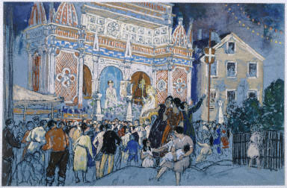

**Step 1: Composition**

* What is the shape of the physical painting?
  + The painting is rectangular
* How are the forms, elements, and any human figures of the painting placed within that shape?
  + Two buildings are in the background of the image and take up the upper two-thirds of the canvas. The building on the left is the largest and the center of attention. People are spread around the bottom third of the canvas, appearing to look at the large building.
* Would you characterize the artist’s composition as symmetrical (balanced) or asymmetrical (unbalanced)? Why or why not?
  + I would characterize the composition as asymmetrical (unbalanced). The first two-thirds of the canvas (left to right) is very busy while the final third of the canvas (far right portion) is relatively empty in comparison to the rest of the canvas.

**Step 2: Line**

* Is the representation of elements in the composition linear, “painterly”, or both in execution?
  + The representation of elements is “painterly” as the coloring of objects in the painting as well as the textures clearly indicate brushstrokes
* How do these linear and “painterly” lines define, order and/or arrange the elements in this composition?
  + These “painterly” lines blend all the elements in the composition uniformly so that rather than them seeming to be individual elements, they are made to appear as a greater whole.
* Is there a clear horizontal line?
  + There is a horizontal line which somewhat separates the people on the bottom half of the image from the rest of the image. The only exception to this is the small group of people in the foreground of the image.

**Step 3: Space**

* How, if at all, is the illusion of space created?
  + The illusion of space is created through the atmospheric perspective as elements in the painting more distant (such as the people closest to the buildings) are depicted with less detail and more ambiguous colors than those closest to the viewer.
* If applicable, how does the illusion of space direct the viewer’s eye? (*Hint: If linear perspective is utilized, lines should direct the viewer’s eye towards the center of the composition.)
  + The use of atmospheric perspective directs the viewer’s eye to where the objects receding into space are meeting, which in this case is the large detailed building to the left.
* If there are no illusionistic devices, why would the artist adopt this strategy?
  + If an artist were to not use illusionistic devices, the purpose may be to not create a sense of space or depth, but rather make it appear as if the elements in the composition are all directly in front of the viewer.

**Step 4: Color**

* Describe the colors used in this painting:
  + The painting is dominated by blues and greys with accents of light brown/orange/tan and red. Overall the colors appear to be signifying nighttime.
* Is the juxtaposition of certain colors jarring and discordant, or harmonic?
  + The color scheme of the painting is generally very dull but has splashes of bright and eye-catching accents of colors as mentioned previously. I would say they work in harmony with each other and do not clash, therefore making them harmonic.
* Does the artist use specific colors to focus the viewer’s attention on a particular part of the painting?
  + The juxtaposition of colors creates points of attention to the viewer amongst a dominantly blueish canvas. For example, it points the viewer’s attention to the large building on the left. As stated previously, the use of blue in this composition serves to create a night like appearance to the overall scene.
* Is the artist’s color system designed to support an illusion of three-dimensional forms in space?
  + Yes, it is meant to support the illusion of three-dimensional space as it uses atmospheric perspective to illustrate depth and dimensionality.

**Step 5: Light**

* Is the image flooded with light, or does light illuminate only particular areas of the composition?
  + The image is not filled with light. It appears to be dark and appears to be taking place at night.
* What and where is the main source of light? Are there multiple sources, or is light diffused throughout the image?
  + The main “source of light” is the leftmost structure dominating most of the painting. It is the brightest element in the painting and attracts most of the viewer’s attention, however, the entire painting in general is dark and is taking place at night. Therefore, there is no natural light source which lightens the elements in the painting.
* Look closely to determine what actual colors, not just black and white, are used to create a sense of light and dark.
  + The blueish and grey colors in the sky are used to create a sense of dark and nighttime.

**Step 6: Brushwork/Handling of the Paint/Texture**

* What is the texture of the brush strokes?
  + The texture appears very soft, smooth, and delicate. There are a lot of intricate details the artist painted which required careful
* How is the artist’s medium implicated in the choice of color techniques?
  + The artist’s medium of pastel is implicated through their use of color that appears to be more dull and white-washed.

**Step 7: Figures**

* Has the artist idealized his/her forms? That is, are they rendered as seemingly perfect and invincible. Or, has the artist sought to portray the human form in a way that acknowledges the imperfections of nature?
  + The artist does not attempt to enhance, idealize, or perfect the human figures in the painting. They are, therefore, made to acknowledge the imperfections of nature.
* Has the artist stylized or abstracted the human forms?
  + The artist has not stylized or abstracted the human forms.
* Collectively, are the figures, or elements, oriented in a specific shape or direction?
  + No, the figures or elements are not oriented in any specific way.

**Step 8: Narrative**

* What does the artist’s composition, use of line and expression of space suggest about the purpose of his/her artwork?
  + The artist’s composition and expression of space in this piece suggests that the piece serves the purpose of illustrating a human interest towards people and things that capture one’s attention. In the case of this painting: what is attracting the crowd of people towards the large building. This is illustrated through the artist’s depiction of a crowded space.
* How does the application of color symbolize a particular concept? How and what is that concept?
  + The artist’s application of color shows the concept of attracting attention as well as depicting night. The artist uses bright colors to grab the viewer’s attention to what appears to be grabbing the attention of the figures in the painting, which is the large building. In addition, the artist uses dark blueish colors to depict a nighttime scene.
* What effect, or moods, does light and shadow achieve?
  + The places of light and shadow create a relatively dark and cool night time mood.
* Does the application of paint and figural representation add a sense of preciousness to the subject or object itself - or the opposite?
  + The application of paint does create a sense of preciousness to the subject, which I believe to be is the large building to the left. The differences in paint color and design sets apart the building from the rest of the painting, adding a sense of importance and beauty to the building. This in conjunction to the fact that the figures in the painting are all facing the building again adds a degree of importance and preciousness to it.

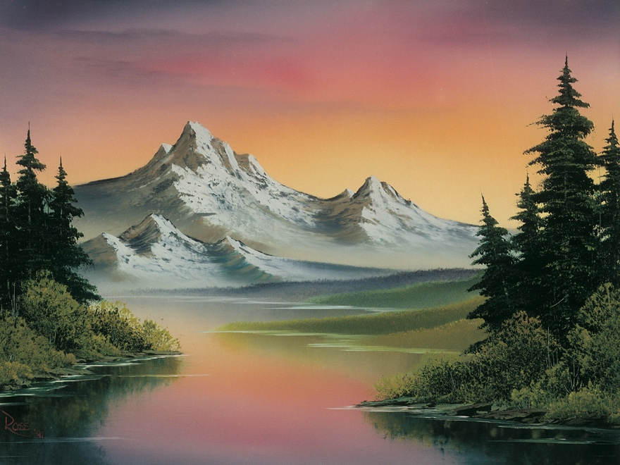

**Step 1: Composition**

* What is the shape of the physical painting?
  + The painting is rectangular
* How are the forms, elements, and any human figures of the painting placed within that shape?
  + The main element in the painting is the mountain in the background of the painting. Two sets of land/trees are on either side of the painting separated by a body of water down the middle.
* Would you characterize the artist’s composition as symmetrical (balanced) or asymmetrical (unbalanced)? Why or why not?
  + I would say the composition is slightly unbalanced. The mountains are not perfectly in the middle of the painting and the land/trees on the right appear to be closer to the middle than the land/trees on the left.

**Step 2: Line**

* Is the representation of elements in the composition linear, “painterly”, or both in execution?
  + The representation of elements is “painterly” as the coloring of objects in the painting as well as the textures clearly indicate brushstrokes and that it was made on a canvas
* How do these linear and “painterly” lines define, order and/or arrange the elements in this composition?
  + These “painterly” lines blend all the elements in the composition uniformly so that rather than them seeming to be individual elements, they are made to appear as a greater whole. Everything in the environment is made to look like it belongs together.
* Is there a clear horizontal line?
  + There is somewhat of a horizontal line from the point where the land/water meets the mountains.

**Step 3: Space**

* How, if at all, is the illusion of space created?
  + The illusion of space is created through the atmospheric perspective as elements in the painting more distant (such as mountains and land further away) are depicted with less detail and with more ambiguous colors than those closest to the viewer (such as the grass at the very front/bottom of the painting)
* If applicable, how does the illusion of space direct the viewer’s eye? (*Hint: If linear perspective is utilized, lines should direct the viewer’s eye towards the center of the composition.)
  + The use of atmospheric perspective directs the viewer’s eye to where the objects receding into space are meeting, which in this case is the body of water leading t
* If there are no illusionistic devices, why would the artist adopt this strategy?
  + If an artist were to not use illusionistic devices, the purpose may be to not create a sense of space or depth, but rather make it appear as if the elements in the composition are all directly in front of the viewer.

**Step 4: Color**

* Describe the colors used in this painting:
  + The painting is composed of “sunset/sunrise type” colors with the sky containing strokes of orange/yellow as well as hints of blue. The water appropriately reflects these colors. The mountains which are the subject of the painting are made primarily white. On either side of the painting, the land is composed of greens and dark browns. Although this painting contains a wide variety of color, overall they are very unsaturated.
* Is the juxtaposition of certain colors jarring and discordant, or harmonic?
  + The juxtaposition of colors in this painting are definitely harmonic. No individual color appears to be jarring from the rest. They all blend together nicely and collectively create a beautiful and serene scene.
* Does the artist use specific colors to focus the viewer’s attention on a particular part of the painting?
  + The white of the mountain contrasts from the other colors in the painting to grab the viewer’s attention as it is the subject of the painting.
* Is the artist’s color system designed to support an illusion of three-dimensional forms in space?
  + Yes, it is meant to support the illusion of three-dimensional space as it uses atmospheric perspective and a blend of lighter and darker shades of the same color to illustrate depth and dimensionality.

**Step 5: Light**

* Is the image flooded with light, or does light illuminate only particular areas of the composition?
  + The image generally appears to be very ‘poorly lit’ as it is attempting to depict a sunset. Therefore, the sky is the lightest area of the painting while everything else is made to be slightly darker to emulate this sunset effect.
* What and where is the main source of light? Are there multiple sources, or is light diffused throughout the image?
  + The main “source of light” is the lighter colors from the sky which is the lightest part of the image. The light colors in the sky are also reflected on the water down the middle of the painting. The colors overall are diffused throughout the painting.
* Look closely to determine what actual colors, not just black and white, are used to create a sense of light and dark.
  + The lighter colors of yellow and orange in the sky are primarily used to create a sense of light. The dark browns and greens of the land are used to create a sense of dark.

**Step 6: Brushwork/Handling of the Paint/Texture**

* What is the texture of the brush strokes?
  + The texture appears very soft, smooth, and delicate. There are a lot of intricate details the artist painted which required careful strokes.
* How is the artist’s medium implicated in the choice of color techniques?
  + The artist’s medium of watercolor is implicated through their use of color that appears to smooth and nontextured.

**Step 7: Figures**

* Has the artist idealized his/her forms? That is, are they rendered as seemingly perfect and invincible. Or, has the artist sought to portray the human form in a way that acknowledges the imperfections of nature?
  + The artist acknowledges the imperfections of nature as none of the elements in the painting are enhanced or idealized. Nature is represented in a non-changed form.
* Has the artist stylized or abstracted the human forms?
  + The artist has not stylized or abstracted the human forms. There are no human figures in the painting.
* Collectively, are the figures, or elements, oriented in a specific shape or direction?
  + No, the figures or elements are not oriented in any specific way.

**Step 8: Narrative**

* What does the artist’s composition, use of line and expression of space suggest about the purpose of his/her artwork?
  + The artist’s composition and expression of space in this piece suggests that the piece serves the purpose of illustrating the beauty of serenity of nature. There is a lot of ‘empty’ and nonbusy space in the painting such as the body of water and the clear skies. This again shows beauty of nature without any man-made presence.
* How does the application of color symbolize a particular concept? How and what is that concept?
  + The artist’s application of color shows the concept of peacefulness and beauty by his use of colors commonly found in a scene in nature.
* What effect, or moods, does light and shadow achieve?
  + The places of light and shadow create a peaceful and calm mood as the light and darkness are not too extreme to either end but rather perfectly blend to emulate a beautiful sunset.
* Does the application of paint and figural representation add a sense of preciousness to the subject or object itself - or the opposite?
  + The application of paint and figural representation does create a sense of preciousness to the subject. The environment is made to look beautiful and specifically unchanged or altered by any human creation, and is therefore made to appear precious in nature. For example, the figure of the body of water does not contain any ripples or splashes. This figural representation of water adds to the impression of undisturbed beauty.